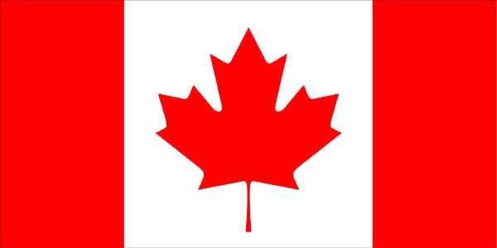
Building Canada and the Constitution
1215 Magna Carta - famous document that required all monarchs to obey the law. It also recognized that the rights of individuals could not be restricted without reason, and as part of this, people had the right to know why they were being imprisoned and to be brought before the courts within a reasonable time.
1629 Petition of Right –Strengthened the concept of rights of the individual by listing specific rights that the Monarch could not infringe upon.
1679 Habeas Corpus Act - this act wrote down the specific rules and procedures to make sure that that a prisoner would not be unlawfully detained.
1689 Bill of Rights – built on previous documents and established the rights of Parliament. Limits were placed on the powers of the crown.
1701 Act of Settlement – placed more limits on the monarchy as well as disqualifying any who were Catholic, or who married a Catholic.
1763 Royal Proclamation – established a line through the Appalachian Mountains as an unofficial border between settlers and native lands. Many modern land claims refer to this document.
1774 Quebec Act – established Quebec as a British colony, but maintained the role of the Catholic Church in society. It did not include an elected assembly.
1791 Constitutional Act – divided the colony of Quebec into Upper and Lower Canada, each with their own elected assembly. Any law however, could be vetoed by the governor.
1867 British North America Act – (also known as the Constitution Act of 1867), set out the powers of the federal and provincial governments as well as guaranteeing basic rights and freedoms. Although this was considered the Constitution of Canada, any changes had to be passed by the British Parliament.
Section 146 of the BNA Act stated that Newfoundland, PEI, British Columbia, Rupert’s Land and the Northwest Territory could all join Confederation by an Act of Parliament when and if they wanted to.
1870 Manitoba Act – an amendment to the BNA act to create the Province of Manitoba.
1870 Hudson Bay Company transfers Rupert’s Land and the North-Western Territory to Canada. This becomes the Northwest Territories but the boundaries will change many times.
1871 British Columbia joined Confederation
1873 Prince Edward Island joined Confederation
1898 Yukon Territory is recognized as a distinct region of Canada.
1905 Alberta and Saskatchewan Acts –further amendments to the BNA act to create the provinces of Alberta and Saskatchewan.
1912 Current borders of Manitoba, Ontario and Quebec are established.
1931 Statute of Westminster – a law passed by the British Parliament that gave Canada control over its foreign affairs.
1949 Newfoundland Act – an amendment to include Newfoundland in confederation.
1960 Bill of Rights – a statute (law) passed by parliament under John Diefenbaker. It established basic rights and freedoms, but as a law, it could easily be changed by parliament.
1982 Canada Act – passed by the British Parliament, it gave control to Canada of its constitution and ended the practice of Canada requesting changes to the Constitution and the British parliament consenting to them.
1982 Constitution Act, 1867 – established two levels of government, federal and provincial. The provincial government has given some of their powers to municipalities. It consists of 3 documents; the Canada Act, the Constitution Act of 1867 and the Canadian Charter of Rights and Freedoms.
1982 Canadian Charter of Rights and Freedoms – was more specific about the rights and freedoms of Canadians and the role of the courts in enforcing them. As the Charter is now part of the Constitution, it requires consent of the provinces before it can be changed.
1999 Territory of Nunavut is established from the eastern part of the Northwest Territories.

